 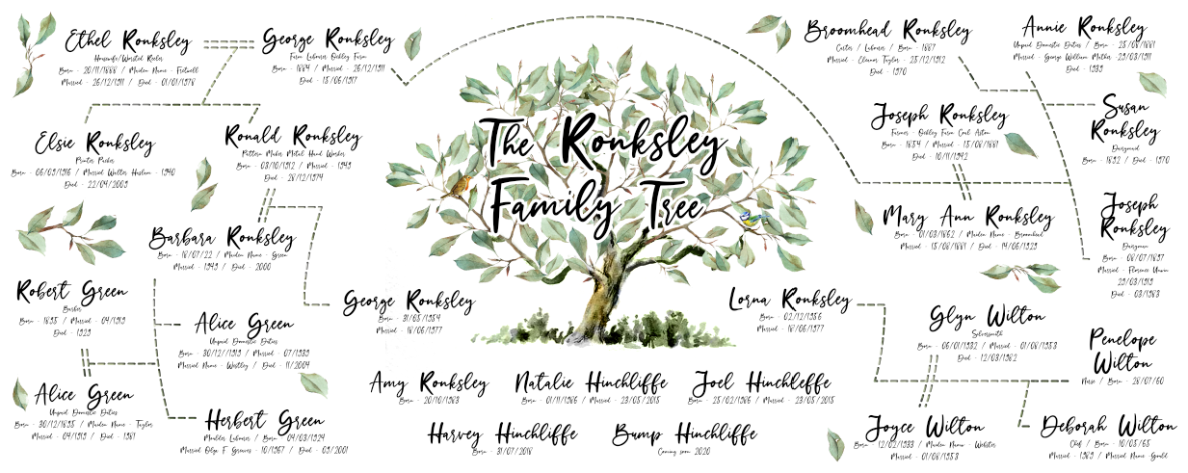

**AmyLiz Designs – Family Tree Print**

Please use the form enclosed and enter your family history research. This form is compatible with most computer word programs – please type your info directly into the corresponding boxes. Once complete please email to: [enquiries@amylizdesigns.co.uk](mailto:enquiries@amylizdesigns.co.uk)

I will not be able to start work on your print until I receive this complete form. Once submitted a digital proof will be emailed across to you within 1-2weeks unless otherwise discussed prior to ordering.

*\*\*Top Tips for filling out\*\**

*You do not need to fill in all the boxes – please fill in only the number of boxes depending on number of names purchased i.e. If you want 14 family members on your family tree print (0-25 names option purchased) please just fill in the required 14 boxes.*

*If you fill in more boxes than option purchased, we will contact you to invoice you the outstanding monies and this will need to be paid prior to us starting your print.*

*Please enter dates exactly as you would like them displaying i.e 20/10/1983 or 20th Oct 1983.*

*If you do not want certain information on your print – i.e. Profession / date of death – please just leave these sections blank.*

*Please double check your spelling and information very carefully, as the information contained in this document will be directly inputted into your family tree.*

If you have any questions / queries regarding this please feel free to get in touch via Etsy or via the email address shown above and I will do my best to help.

I look forward to working on your Print

X Amy

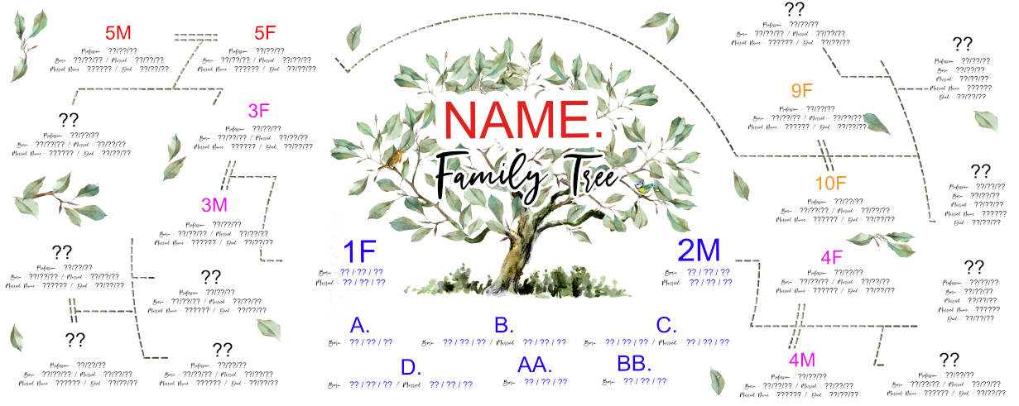 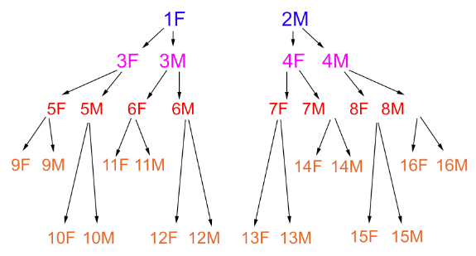

**1st GENERATION: RECIPIENTS / KIDS / GRANDKIDS (IN CENTER OF TREE)**

| **FAMILY NAME** | Doneux |
| --- | --- |

| **RECIPIENTS** | **1F (Father)** | **2M (Mother)** |
| --- | --- | --- |
| Name | Robert Doneux | Megan Doneux |
| Born (Date of Birth) | 17/07/1991 | 17/04/1991 |
| Profession |  |  |
| Maiden Name (if applicable) | n/a | Hunter |
| Date Married | 18/08/2018 | 18/08/2018 |
| Died (Date of Death) |  |  |

| **CHILDREN + SPOUSES** | **A** | **B** | **C** | **D** |
| --- | --- | --- | --- | --- |
| Name | Jack Doneux |  |  |  |
| Born (Date of Birth) | 24/08/2021 |  |  |  |
| Profession |  |  |  |  |
| Maiden / Married Name (if applicable) |  |  |  |  |
| Date Married |  |  |  |  |
| Died (Date of Death) |  |  |  |  |

*\*\* If additional children / spouses please copy and paste columns*

| **GRANDCHILDREN** | **AA** | **BB** | **CC** | **DD** |
| --- | --- | --- | --- | --- |
| Name |  |  |  |  |
| Born (Date of Birth) |  |  |  |  |
| Profession |  |  |  |  |
| Maiden / Married Name (if applicable) |  |  |  |  |
| Date Married |  |  |  |  |
| Died (Date of Death) |  |  |  |  |

*\*\* If additional grandchildren please copy and paste columns*



**2nd GENERATION: PARENTS OF RECIPIENTS + SIBLINGS**

| **PARENTS OF 1F + 2M** | **3F**  **(1F- Father)** | **3M**  **(1F- Mother)** | **4F**  **(2M- Father)** | **4M**  **(2M- Mother)** |
| --- | --- | --- | --- | --- |
| Name | Peter Doneux | Sara Doneux | Anthony Hunter | Joanne Hunter |
| Born (Date of Birth) | 06/11/1954 | 28/11/1964 | 10/10/1956 | 29/03/1960 |
| Profession |  |  |  |  |
| Maiden / Married Name (if applicable) | n/a | Edney | n/a | Gallimore |
| Date Married |  |  |  |  |
| Died (Date of Death) |  |  |  |  |

| **CHILDREN OF 3F + 3M**  **SIBLINGS OF 1F** | **1** | **2** | **3** | **4** |
| --- | --- | --- | --- | --- |
| Name |  |  |  |  |
| Born (Date of Birth) |  |  |  |  |
| Profession |  |  |  |  |
| Maiden / Married Name (if applicable) |  |  |  |  |
| Date Married |  |  |  |  |
| Died (Date of Death) |  |  |  |  |

*\*\* If additional children / siblings please copy and paste columns*

| **CHILDREN OF 4F + 4M SIBLINGS OF 2M** | **1** | **2** | **3** | **4** |
| --- | --- | --- | --- | --- |
| Name | Matthew Hunter | Natasha Hunter |  |  |
| Born (Date of Birth) | 02/04/1997 | 05/09/2009 |  |  |
| Profession |  | (father: Anthony Hunter  mother: Aniko Kormendi) |  |  |
| Maiden / Married Name (if applicable) |  |  |  |  |
| Date Married |  |  |  |  |
| Died (Date of Death) |  |  |  |  |

*\*\* If additional children / siblings please copy and paste columns*



**3rd GENERATION: GRANDPARENTS OF RECIPIENT (FATHER) + THEIR CHILDREN**

| **PARENTS OF 3F (GRANDPARENTS OF 1F)** | **5F (Father of 3F)** | **5M (Mother of 3F)** |
| --- | --- | --- |
| Name | Jacques Doneux | Daphne Doneux |
| Born (Date of Birth) |  |  |
| Profession |  |  |
| Maiden Name (if applicable) | n/a | Edwards |
| Date Married |  |  |
| Died (Date of Death) |  |  |

| **CHILDREN OF 5F + 5M** | **1** | **2** | **3** | **4** |
| --- | --- | --- | --- | --- |
| Name |  |  |  |  |
| Born (Date of Birth) |  |  |  |  |
| Profession |  |  |  |  |
| Maiden / Married Name (if applicable) |  |  |  |  |
| Date Married |  |  |  |  |
| Died (Date of Death) |  |  |  |  |

*\*\* If additional children / siblings please copy and paste columns*

| **PARENTS OF 3M (GRANDPARENTS OF 1F)** | **6F (Father of 3M)** | **6M (Mother of 3M)** |
| --- | --- | --- |
| Name | James Edney | Brenda Edney |
| Born (Date of Birth) |  |  |
| Profession |  |  |
| Maiden Name (if applicable) | n/a | Maddock |
| Date Married |  |  |
| Died (Date of Death) |  |  |

| **CHILDREN OF 6F + 6M** | **1** | **2** | **3** | **4** |
| --- | --- | --- | --- | --- |
| Name |  |  |  |  |
| Born (Date of Birth) |  |  |  |  |
| Profession |  |  |  |  |
| Maiden / Married Name (if applicable) |  |  |  |  |
| Date Married |  |  |  |  |
| Died (Date of Death) |  |  |  |  |

*\*\* If additional children / siblings please copy and paste columns*



**3rd GENERATION: GRANDPARENTS OF RECIPIENT (MOTHER) + THEIR CHILDREN**

| **PARENTS OF 4F (GRANDPARENTS OF 1M)** | **7F (Father of 4F)** | **7M (Mother of 4F)** |
| --- | --- | --- |
| Name | Gordon Hunter | Joy Hunter |
| Born (Date of Birth) |  |  |
| Profession |  |  |
| Maiden Name (if applicable) | n/a | Downing |
| Date Married |  |  |
| Died (Date of Death) |  |  |

| **CHILDREN OF 7F + 7M** | **1** | **2** | **3** | **4** |
| --- | --- | --- | --- | --- |
| Name |  |  |  |  |
| Born (Date of Birth) |  |  |  |  |
| Profession |  |  |  |  |
| Maiden / Married Name (if applicable) |  |  |  |  |
| Date Married |  |  |  |  |
| Died (Date of Death) |  |  |  |  |

*\*\* If additional children / siblings please copy and paste columns*

| **PARENTS OF 4M (GRANDPARENTS OF 1M)** | **8F (Father of 4M)** | **8M (Mother of 4M)** |
| --- | --- | --- |
| Name | William Gallimore | Margaret Gallimore |
| Born (Date of Birth) |  | 2nd Marriage to Arthur Sergeant |
| Profession |  |  |
| Maiden Name (if applicable) | n/a | Collins |
| Date Married |  |  |
| Died (Date of Death) |  |  |

| **CHILDREN OF 6F + 6M** | **1** | **2** | **3** | **4** |
| --- | --- | --- | --- | --- |
| Name |  |  |  |  |
| Born (Date of Birth) |  |  |  |  |
| Profession |  |  |  |  |
| Maiden / Married Name (if applicable) |  |  |  |  |
| Date Married |  |  |  |  |
| Died (Date of Death) |  |  |  |  |

*\*\* If additional children / siblings please copy and paste columns*



**4th GENERATION: GREAT GRANDPARENTS OF RECIPIENT (FATHER) + THEIR CHILDREN**

| **PARENTS OF 5F (GREAT GRANDPARENTS OF 1F)** | **9F (Father of 5F)** | **9M (Mother of 5F)** |
| --- | --- | --- |
| Name | Jean Doneux | Hélène Doneux |
| Born (Date of Birth) |  |  |
| Profession |  |  |
| Maiden Name (if applicable) |  |  |
| Date Married |  |  |
| Died (Date of Death) |  |  |

| **CHILDREN OF 9F + 9M** | **1** | **2** | **3** | **4** |
| --- | --- | --- | --- | --- |
| Name |  |  |  |  |
| Born (Date of Birth) |  |  |  |  |
| Profession |  |  |  |  |
| Maiden / Married Name (if applicable) |  |  |  |  |
| Date Married |  |  |  |  |
| Died (Date of Death) |  |  |  |  |

*\*\* If additional children / siblings please copy and paste columns*

| **PARENTS OF 5M (GREAT GRANDPARENTS OF 1F)** | **10F (Father of 5M)** | **10M (Mother of 5M)** |
| --- | --- | --- |
| Name | William Edwards | Ethel Edwards |
| Born (Date of Birth) |  |  |
| Profession |  |  |
| Maiden Name (if applicable) |  |  |
| Date Married |  |  |
| Died (Date of Death) |  |  |

| **CHILDREN OF 10F + 10M** | **1** | **2** | **3** | **4** |
| --- | --- | --- | --- | --- |
| Name |  |  |  |  |
| Born (Date of Birth) |  |  |  |  |
| Profession |  |  |  |  |
| Maiden / Married Name (if applicable) |  |  |  |  |
| Date Married |  |  |  |  |
| Died (Date of Death) |  |  |  |  |

*\*\* If additional children / siblings please copy and paste columns*



**4th GENERATION: GREAT GRANDPARENTS OF RECIPIENT (FATHER) + THEIR CHILDREN contd….**

| **PARENTS OF 6F (GREAT GRANDPARENTS OF 1F)** | **11F (Father of 6F)** | **11M (Mother of 6F)** |
| --- | --- | --- |
| Name | Joseph Edney | Alice Edney |
| Born (Date of Birth) |  |  |
| Profession |  |  |
| Maiden Name (if applicable) | n/a |  |
| Date Married |  |  |
| Died (Date of Death) |  |  |

| **CHILDREN OF 11F + 11M** | **1** | **2** | **3** | **4** |
| --- | --- | --- | --- | --- |
| Name |  |  |  |  |
| Born (Date of Birth) |  |  |  |  |
| Profession |  |  |  |  |
| Maiden / Married Name (if applicable) |  |  |  |  |
| Date Married |  |  |  |  |
| Died (Date of Death) |  |  |  |  |

*\*\* If additional children / siblings please copy and paste columns*

| **PARENTS OF 6M (GREAT GRANDPARENTS OF 1F)** | **12F (Father of 6M)** | **12M (Mother of 6M)** |
| --- | --- | --- |
| Name | Fred Maddock | Ann Maddock |
| Born (Date of Birth) |  |  |
| Profession |  |  |
| Maiden Name (if applicable) | n/a |  |
| Date Married |  |  |
| Died (Date of Death) |  |  |

| **CHILDREN OF 12F + 12M** | **1** | **2** | **3** | **4** |
| --- | --- | --- | --- | --- |
| Name |  |  |  |  |
| Born (Date of Birth) |  |  |  |  |
| Profession |  |  |  |  |
| Maiden / Married Name (if applicable) |  |  |  |  |
| Date Married |  |  |  |  |
| Died (Date of Death) |  |  |  |  |

*\*\* If additional children / siblings please copy and paste columns*



**4th GENERATION: GREAT GRANDPARENTS OF RECIPIENT (MOTHER) + THEIR CHILDREN**

| **PARENTS OF 7F (GREAT GRANDPARENTS OF 2M)** | **13F (Father of 7F)** | **13M (Mother of 7F)** |
| --- | --- | --- |
| Name | Norman Hunter | Gertrude Hunter |
| Born (Date of Birth) |  |  |
| Profession |  |  |
| Maiden Name (if applicable) |  |  |
| Date Married |  |  |
| Died (Date of Death) |  |  |

| **CHILDREN OF 13F + 11M** | **1** | **2** | **3** | **4** |
| --- | --- | --- | --- | --- |
| Name |  |  |  |  |
| Born (Date of Birth) |  |  |  |  |
| Profession |  |  |  |  |
| Maiden / Married Name (if applicable) |  |  |  |  |
| Date Married |  |  |  |  |
| Died (Date of Death) |  |  |  |  |

*\*\* If additional children / siblings please copy and paste columns*

| **PARENTS OF 7M (GREAT GRANDPARENTS OF 2M)** | **14F (Father of 7M)** | **14M (Mother of 7M)** |
| --- | --- | --- |
| Name | Herbert Downing | Millicent Downing |
| Born (Date of Birth) |  |  |
| Profession |  |  |
| Maiden Name (if applicable) | n/a |  |
| Date Married |  |  |
| Died (Date of Death) |  |  |

| **CHILDREN OF 14F + 14M** | **1** | **2** | **3** | **4** |
| --- | --- | --- | --- | --- |
| Name |  |  |  |  |
| Born (Date of Birth) |  |  |  |  |
| Profession |  |  |  |  |
| Maiden / Married Name (if applicable) |  |  |  |  |
| Date Married |  |  |  |  |
| Died (Date of Death) |  |  |  |  |

*\*\* If additional children / siblings please copy and paste columns*



**4th GENERATION: GREAT GRANDPARENTS OF RECIPIENT (MOTHER) + THEIR CHILDREN contd….**

| **PARENTS OF 8F (GREAT GRANDPARENTS OF 2M)** | **15F (Father of 8F)** | **15M (Mother of 8F)** |
| --- | --- | --- |
| Name | Thomas Gallimore | Myra Gallimore |
| Born (Date of Birth) |  |  |
| Profession |  |  |
| Maiden Name (if applicable) | n/a |  |
| Date Married |  |  |
| Died (Date of Death) |  |  |

| **CHILDREN OF 15F + 15M** | **1** | **2** | **3** | **4** |
| --- | --- | --- | --- | --- |
| Name |  |  |  |  |
| Born (Date of Birth) |  |  |  |  |
| Profession |  |  |  |  |
| Maiden / Married Name (if applicable) |  |  |  |  |
| Date Married |  |  |  |  |
| Died (Date of Death) |  |  |  |  |

*\*\* If additional children / siblings please copy and paste columns*

| **PARENTS OF 8M (GREAT GRANDPARENTS OF 2M)** | **16F (Father of 8M)** | **16M (Mother of 8M)** |
| --- | --- | --- |
| Name | George Collins | Katherine Collins |
| Born (Date of Birth) |  |  |
| Profession |  |  |
| Maiden Name (if applicable) | n/a |  |
| Date Married |  |  |
| Died (Date of Death) |  |  |

| **CHILDREN OF 16F + 16M** | **1** | **2** | **3** | **4** |
| --- | --- | --- | --- | --- |
| Name |  |  |  |  |
| Born (Date of Birth) |  |  |  |  |
| Profession |  |  |  |  |
| Maiden / Married Name (if applicable) |  |  |  |  |
| Date Married |  |  |  |  |
| Died (Date of Death) |  |  |  |  |

*\*\* If additional children / siblings please copy and paste columns*